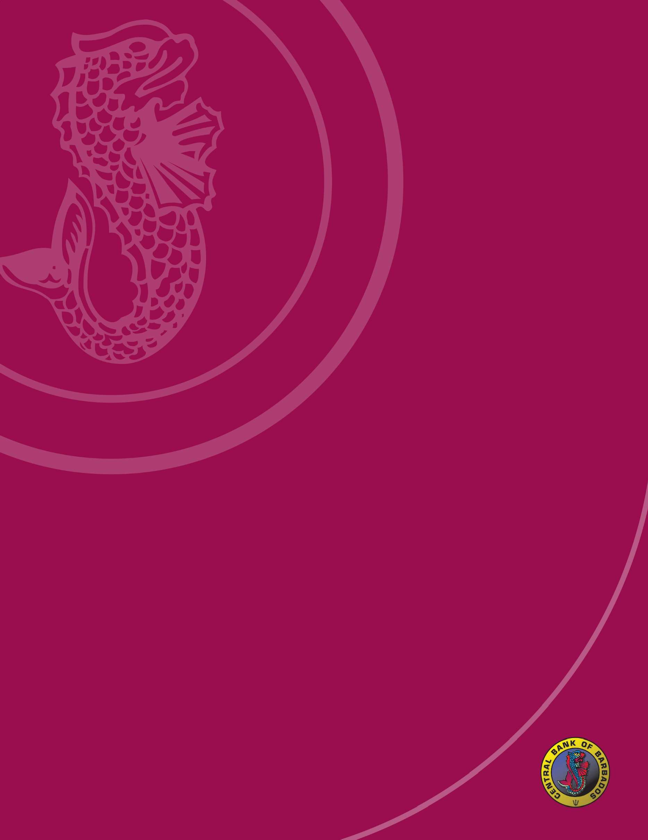
Financial Inclusion and Community Resilience: Building Economic Pathways to Peace
Welcome Remarks by Governor Dr. Kevin Greenidge

Saturday, September 20, 2025

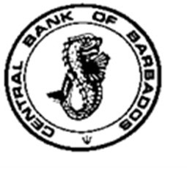
Central Bank of Barbados
Tom Adams Financial Centre, Spry Street, Bridgetown
P.O. Box 1016
Telephone: (246) 436-6870: Fax. (246) 436-7836
E-Mail Address: info@centralbank.org.bb Website: www.centralbank.org.bb

Financial Inclusion and Community Resilience: Building Economic Pathways to Peace

Good evening.

I want to begin by thanking the Tyrese Caesar Foundation Against Gun Violence for the invitation to speak tonight. I honour the life and legacy that brought us together and I honour every mother, father, friend, and neighbour who chooses peace today. We gather not to admire problems, but to activate solutions. For me, peace is not the absence of trouble. Peace is the inner and social alignment that removes the need to fight. When we build that alignment into our economy, we make peace practical. Tonight’s theme, “Financial Inclusion and Community Resilience: Building Economic Pathways to Peace,” is exactly that work and could not be more relevant for our time, and for our country.

Here is my thesis for tonight: Peace is the state of full alignment. When people gain access, agency, and assets, communities settle into that state and violence loses oxygen.

Why should a Central Bank speak about peace? A stable, inclusive financial system reduces anxiety, expands choices, and builds trust. That is not abstract. Families with a safe place to save, a low cost way to pay, and a fair source of credit live with fewer shocks and less desperation. Money does not buy peace. Dignity buys peace, and inclusion delivers dignity at scale. In that sense, financial inclusion is a peace building tool.

Let me offer a definition of Peace for this moment. I see it, peace is coherence; it is minds, hearts, policies and structures moving in the same direction. In a person, it feels like steadiness. In a community, it looks like fewer conflicts and more cooperation. In an economy, it looks like clear rules, reliable access, and the sense that effort creates opportunity.

What does exclusion versus inclusion and alignment look like? We know the faces of exclusion: the school leaver who cannot get a foothold; the young woman with ideas and drive but no pathway to start-up capital; the parent facing a sudden medical bill without savings. Exclusion isolates people, pushes them into informal systems where risk is high and security is low, and often breeds frustration. Inclusion reverses that dynamic. When we extend fair access, agency, and basic assets, we cool tempers and raise horizons.

We must also provide a bridge from inclusion to safety. Violence thrives where hope shrinks. Inclusion expands hope through three pathways:
- Access: Everyone needs a simple account, reliable identification, and low-cost digital payments. This is why we advanced a Market Conduct Guideline for fairness and transparency, strengthened public education, and are building the national instant payment system, BiMPay, scheduled to begin March 31, 2026. These steps reduce cash-based risk, ease remittances, and help small businesses move faster and safer.

- Agency: Agency means people know what to do, feel safe doing it, and can get help when they need it. In other words, they have the skills, confidence, and fair support to use their money tools to reach their goals.
- Let me break it down:
Skills: You know how to budget, save, pay, and borrow wisely.
Confidence: You feel in control of your choices, not afraid of the system.
Fair support: Clear rules, simple information, and a place to get help if something goes wrong.
Real choice: You can compare options and pick what suits you.
- Some quick examples:
- Having a bank account is access. Knowing how to use it to save for school and avoid fees is agency.
- A teen vendor who can price goods, track sales, and set money aside has agency.
- A parent who can read a loan offer, ask the right questions, and complain to a real person if treated unfairly has agency.

- Assets: Jobs, skills, and small pools of capital. Micro savings, micro insurance, and seed funding for community enterprises change the conversation on the block. A barber with a small loan and digital payments hires an assistant. A fisherman with insurance returns after a storm. Ownership quiets streets.

The Central Bank stands at the junction of policy and people. We can:

- Set standards that protect the vulnerable, including simple, low fee accounts and transparent pricing.
- Champion interoperable digital payments so every citizen can pay, save, and receive safely.
- Convene banks, credit unions, fintechs, and NGOs to co design inclusion projects in high risk communities.
- Scale financial literacy with practical content in schools, youth clubs, and churches.
- Publish data that tracks inclusion so communities can see progress and hold all of us to account. These are peace tools, not just policy items.
Community resilience is also a key component of the peace infrastructure. Resilience means a family can take a hit and recover. It means a shop can reopen after a shock. It means a neighbourhood can settle disputes without reaching for a weapon. Savings groups, emergency funds, and quick pay social support create a protective field around households. Paired with after school programmes, arts, and sport, we build a living network that cools Temperatures before conflict ignites.

To our young men: your power is real. Aim it. Learn a trade, start a micro enterprise, master your money. You protect your community when you protect your future.

To our mothers: your influence shapes the next economy. When you organise saving circles, insist on fair fees, and teach your children the value of work and kindness, you finance peace.

This Foundation turns grief into agency. Together we can deliver targeted financial education in hotspot communities, match savings for youth projects, and small peace grants for credible community leaders who provide safe spaces and jobs. The Bank can convene, standardise, and measure. The Foundation can mobilise, mentor, and maintain momentum. That is how we build pathways to peace, not just statements about peace.

In closing, let me emphasize that peace will not arrive by accident. We must build it into the way people earn, pay, save, learn, and resolve their financial matters. When policy meets presence and inclusion meets dignity, streets grow quiet. Let us choose the practical courage to make peace visible in every transaction, every classroom, and every corner shop. May the peace that surpasses understanding settle in our hearts and flow through our hands tonight.

